Sbl Diaboherb Capsule 100's

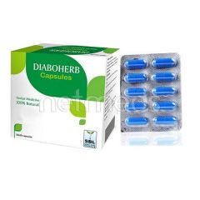

**Price:**   
**Rs 144.00**

# Sbl Burn-Rel Spray 50 Ml

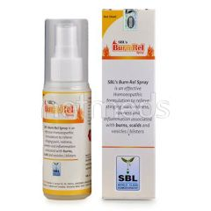

**Price:**   
**Rs 52.00**

# Sbl Kalmegh Drops 30 ml

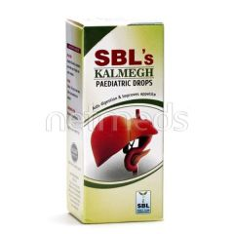

**Price:**   
**Rs 49.00**

# Sbl Pimplex Tablets 25 gm

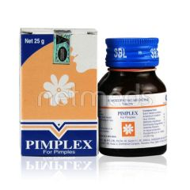

**Price:**   
**Rs 91.00**

# Sbl Homoeopathic Home Kit 1's

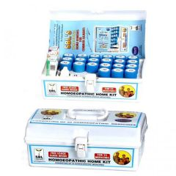

**Price:**   
**Rs 765.00**